**Learning Outcomes**

1. Simple ListView Control
2. Understanding ListActivity and ArrayAdapter

**ListActivity**

Android includes built-in ListActivity that you can use without defining any custom layout XML or code. The ListActivity class automatically creates a ListView and exposes a ListAdapter property to supply the row views to display via an adapter.

**SimpleListItem1**

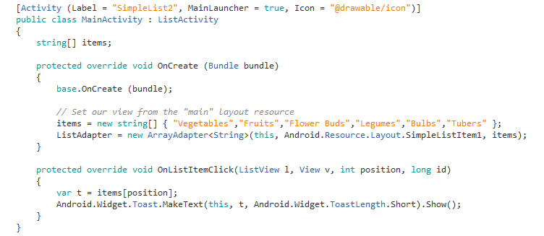

**Points to Note**

Inheriting your main activity as a ListActivity

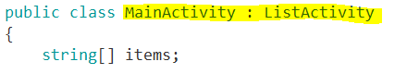

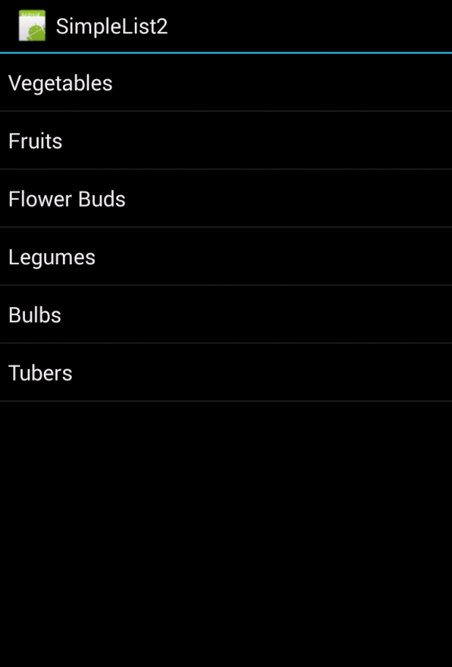

**Variations**

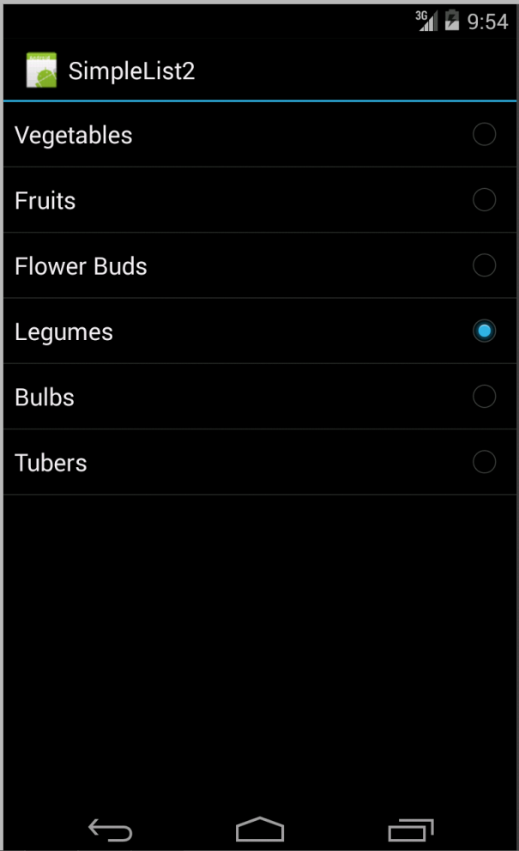

**For a Single Selected Item**

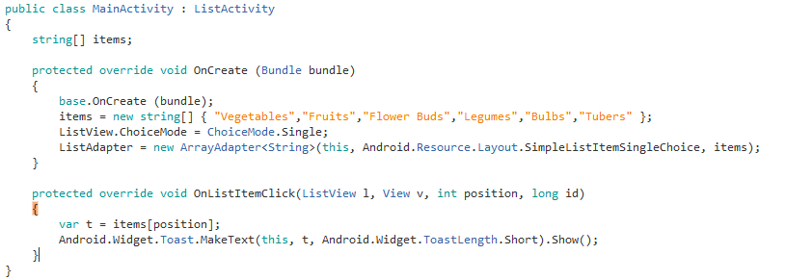

Note the difference



**For Multiple Selection**

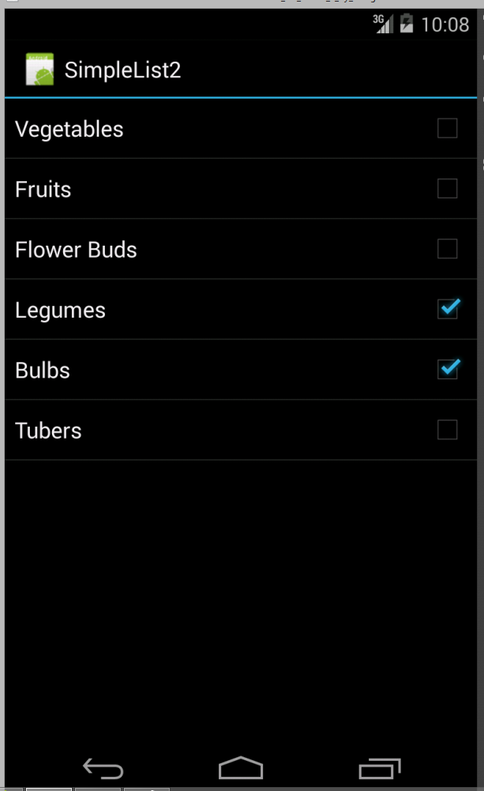

**Modify the code as follows**

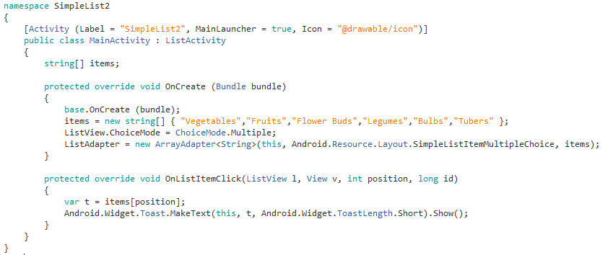

**Simple GroceryList App**

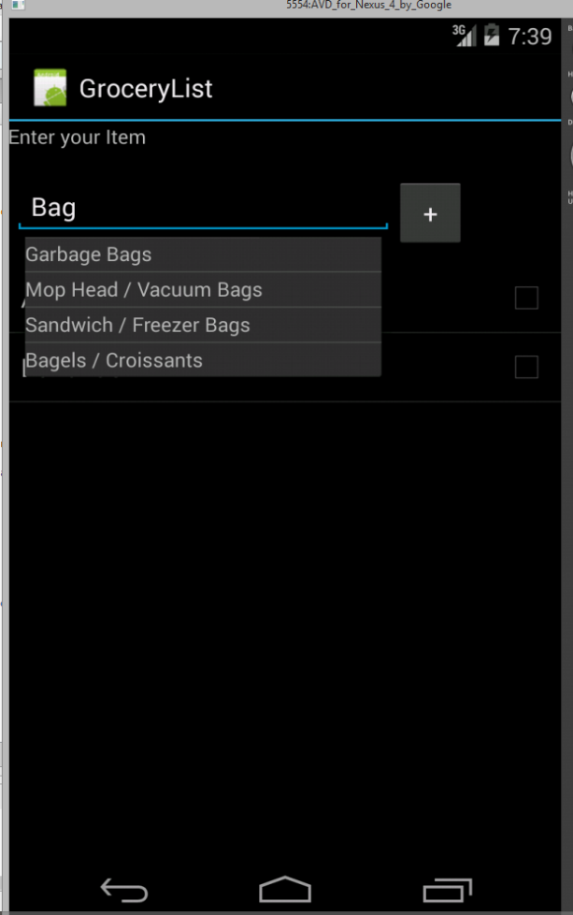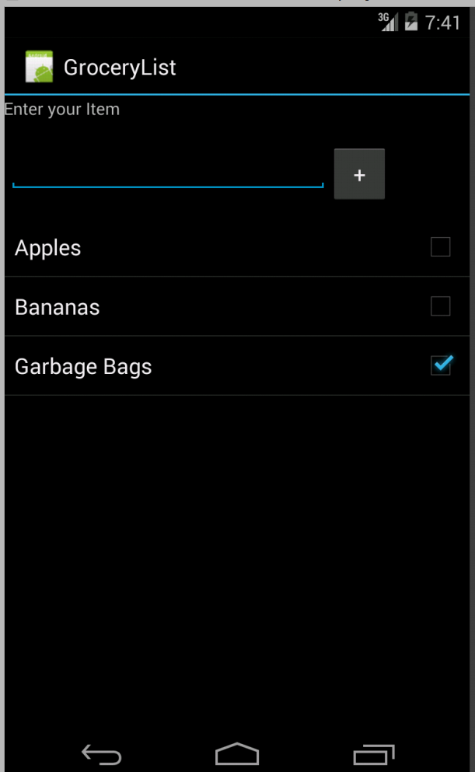

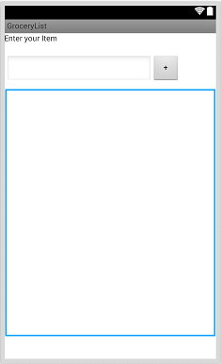

Label, autocomplete textbox, button and a listview

*Add your grocery Items in Strings.xml*

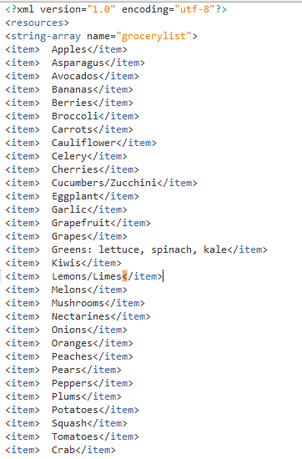

**Code**

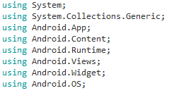

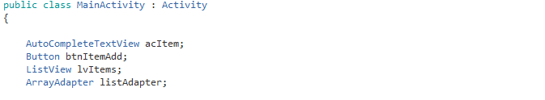

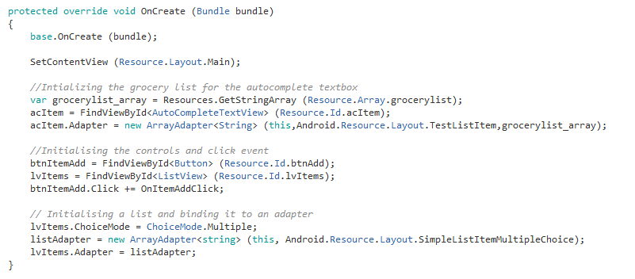

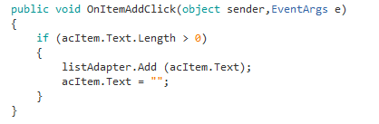

**Send Text Message to Contacts (Bulk Texting)**

In this app the user can send a text to multiple users. The app allows you to select a number of users and send them a text.

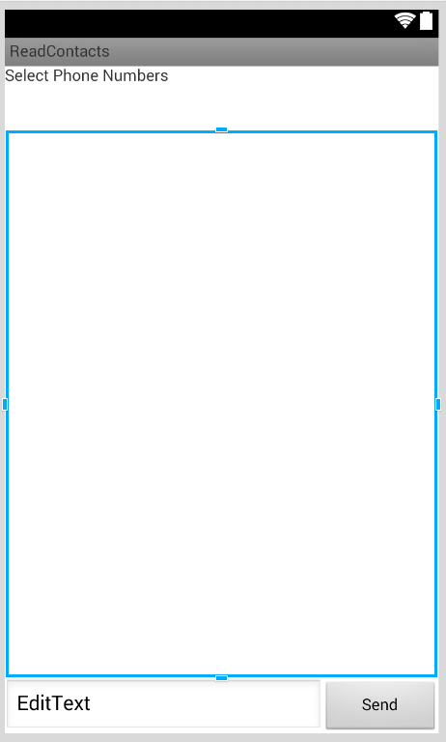

Permission required are SendSMS and Read Contacts. The permissions are set in the AndroidManifest.xml file.

In Visual Studio you can do it via Project Properties.

Go to Project -> (Project Name) Properties

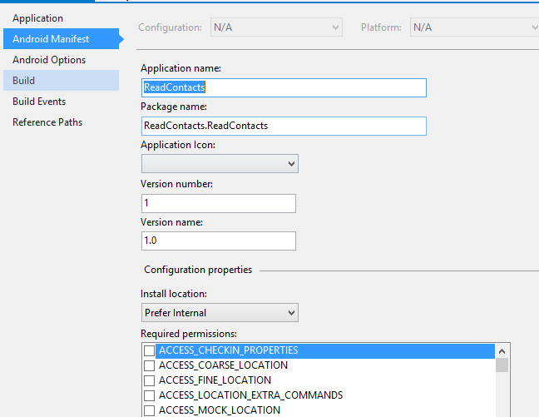





Need to add the Xamarine.Mobile component to be able to read contacts of your phone.

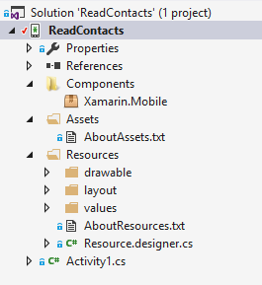

Add the appropriate using directives

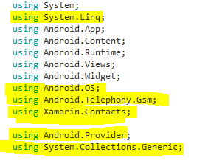

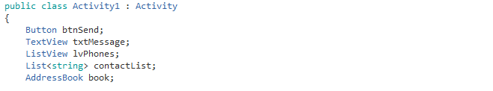

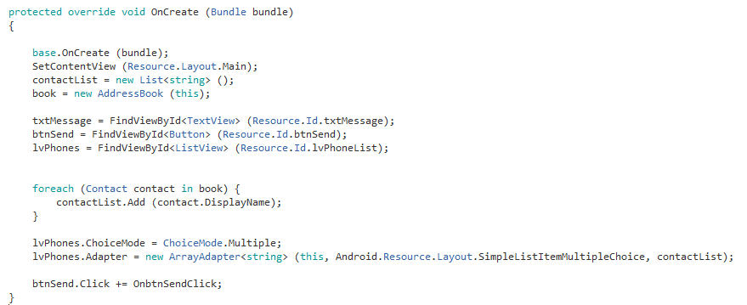

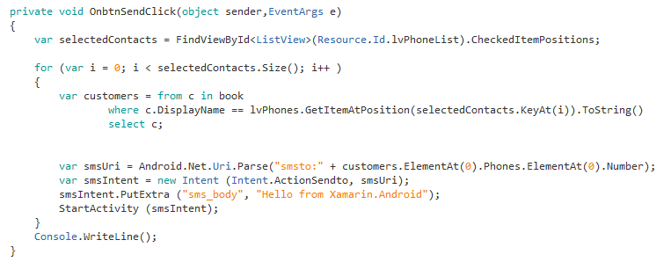

This approach needs you to press the send button to send the text.

Find a way to automatically send the text message.